ONE MILE DAM (AKA RAILWAY DAM) SPL – BACKGROUND.
An extract from: “A Report of a ‘Desktop’ Ethnographic Survey of Inpex's Area of Interest at Blaydin Point and Darwin Harbour and Howard Springs Accommodation Village” A report for INPEX Browse Ltd by Dr William B Day, March 2012.

Aboriginal people of Darwin: One Mile Dam

Introduction
‘One Mile Dam’ is an Aboriginal village on a 3.2 hectare lease granted to Aborigines in 1979. The area has been registered as Site 5073-115 by the Aboriginal Areas Protection Authority, who describe the site as ‘a spring area close to the Darwin CBD, off Dinah Beach Road, that was dug out and dammed in 1897 to create One Mile (or Railway) Dam.’ As a case study, the experience of the One Mile Dam community reveals that so-called Aboriginal representative bodies may not represent all those that they profess to represent, or may even be in active or passive opposition to different sections of the ‘Aboriginal community’ who may be left without a recognised voice. Therefore companies purporting to be acting for the good of one section may in fact be assisting to suppress another.

The needs of the Aboriginal people who camped near the dam first came to the public’s attention in a newspaper report headed, ‘Dinah Beach campers complain of neglect.’ The article continued, ‘For 15 years they have camped on an area behind Dinah Beach which they call Japanee Beach. The camp has no shelter, no toilet facilities and no water supply. They said they prefer to stay at the camp rather than at Bagot Reserve or even their home country at Delissaville because there was ‘too much trouble there.’ The group were mainly Wadjiginy people from the Cox Peninsula, but with strong ties to the Larrakia people at Kulaluk, with whom they had joined in a coalition of fringe dwellers pursuing land rights in Darwin (see Day 1994; 1997b).

As a result of their campaign for land rights, the claim for One Mile Dam was considered by the Aboriginal Land Rights Commissioner, Mr Justice Woodward, who discussed the claim in his final report: (Woodward 1974:54-55):
The second case I want to refer to is that of the area known as One-Mile Dam or Railway Dam. This is a place at which a number of Aborigines have been camped over a period of years. They have recently formed themselves into the Raknurara Bootong Association Incorporated and submissions have been made to me by counsel [John Waters] on behalf of that Association. They have obtained the services of an architect to show how this area could be developed as a semi-permanent Aboriginal campsite. They put the case to the Darwin Town Planning Board at the same time that a case was being put that some part of the land should be made available as a campsite for transients other than Aborigines. The Town Planning board approved the use of the area as a campsite for Aborigines and others but the Administrator’s Council rejected both the recommendations in favour, as I understand it of the use of the land for purpose of a public park. It seems that the proponents of the use of part of the land for non-Aborigines have accepted the defeat of their proposals and are now looking elsewhere. However the Raknurara Bootong Association is pressing its claims on behalf of Aborigines. I can only say that, in pursuance of the principles outlined above, this seems to be a case where Aboriginal wishes should be me. Where else is it suggested that they should camp? Why should they not have reserved for their use the area which they have use for a number of years? There may be answers to these questions but, on the face of it, it seems to me that this claim on behalf of Aborigines is well founded and should receive sympathetic consideration form the relevant authorities – particularly in view of the support of the Town Planning Board.

The Special Purpose Lease
In 1975 the Aboriginal claim to the site was heard by the Interim Aboriginal Land Commissioner, Dick Ward (1975c) whose recommendations came into effect on March 26, 1979, when the title to the land was handed to a representative of the community by the Minister for Lands and Housing Marshall Perron. In an on-site ceremony, Mr Perron said, ‘It will provide a permanent place for Aboriginal people to stay when they come to Darwin. It is best for all concerned if land is allocated and used to meet the needs of Aborigines who wish to live as a community in the urban environs. The people can now move to make improvements to their surroundings confident they have secure title to the area.’

As it turned out, Special Purpose Lease 454 is held by the Aboriginal Development Foundation, an ‘umbrella’ group which also holds the lease for the Knuckeys Lagoon town camp, on the outskirts of Darwin. Although improvements were originally made, the relationship between the ADF and the community residents worsened and the infrastructure fell into a state of neglect. An observer wrote: ‘The lack of services here was very apparent when I visited in July 2004. The camp was set up for indigenous people in the 1970s and has received little help or improvement since then. This camp can swell to accommodate nearly 200 people and has only 2 toilets, piles of refuse fester in the heat and recent reports have cited faulty wiring exposing residents to danger of electrocution’ (Spencer 2006).

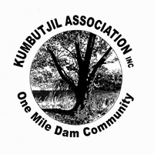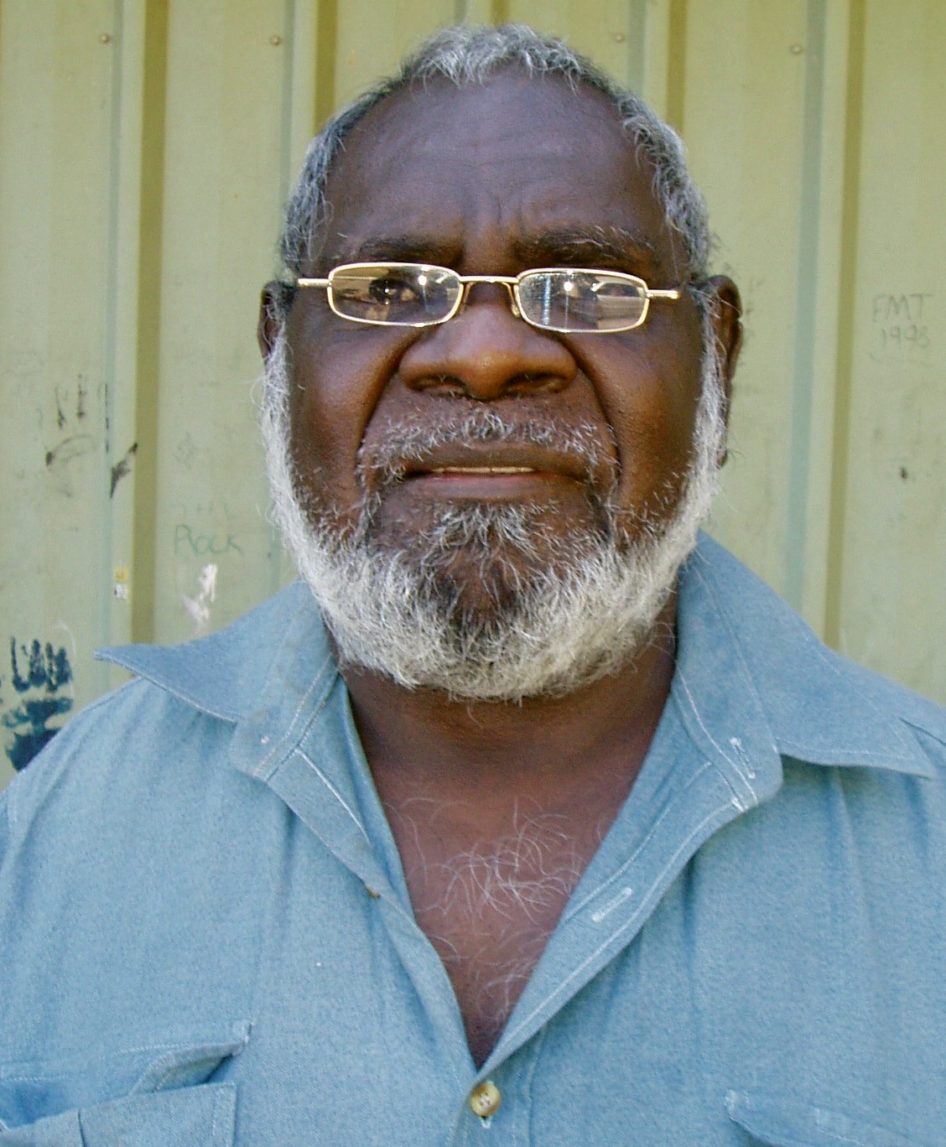
Plate 1: Community Logo. Plate 2: David Timber (Photo: B Day).

Central Darwin Land Use Objectives
By 1996, the media reported that plans were being made by the NT Government to remove the surrounding oil tanks and rezone the hillsides for prestige housing overlooking the One Mile Dam which was shown on maps as ‘public open space’. Warwick Stanley (1996) wrote: ‘The NT Government is set to order the closure of a well-established and well-maintained Aboriginal town camp in the heart of Darwin. The Railway Dam camp site houses up to 12 Aboriginal families and also hosts remote community visitors.’ As the NT Minister for Lands, Planning and Environment, Mike Reed, stated in the media: ‘[The tank farm] will be a class residential development close to the Central Business District of Darwin, very convenient for people, offering great opportunities for development and a good place to live - and it will include large areas of open space.’

The OMD community’s fears were confirmed in February 1997 when the following public notice appeared in the Northern Territory News:
THE NORTHERN TERRITORY PLANNING ACT
Proposed Land Use Objectives for the Railway Dam locality
Due to public interest generated by the inclusion of the objective to relocate the Railway Dam Aboriginal Living Area as part of the recently declared “Central Darwin Land Use Objectives”, land use objectives relevant to the Railway Dam locality are now being exhibited for public comment.
Proposed Land Use Objectives for the Railway Dam locality will be on public exhibition from 28 February to 31 March 1997. The proposed objectives can be viewed during business hours at the Department of Lands, Planning and Environment

In response a pamphlet prepared by the Northern Land Council and the ADF was distributed, headed ‘Railway Dam: how Aboriginal people are being thrown out of their home in Darwin city’ (NLC 1997). As well as quoting Marshall Perron’s promise of permanency, the pamphlet noted:

Housing at the dam is home to more than 30 permanent residents. It also provides accommodation to people visiting Darwin from remote areas... The Government plans to relocate the tank farm as part of its Land Use Objectives. The region will then be redeveloped as a high-density residential precinct. Railway Dam would be part of the public park planned for the area.

Under the heading, ‘Larrakia people support the residents of Railway Dam’, the pamphlet announced that ‘Darwin’s traditional owners have thrown their support behind the bid to save the Aboriginal lease to Railway Dam (also known as One Mile Dam).’ According to the pamphlet, Larrakia elders explained that the dam was a site of an important dreaming story. The dam was also the site of a spring that Larrakia people had pointed out to Goyder when he first came to Darwin. It had been an important meeting and camping place since before living memory. Larrakia spokesperson, Bill Risk, said, ‘We did not and do not approve of any development in this area which requires the eviction of long-term Aboriginal residents from important Larrakia country ... This kind of action can only add to the distrust of NT authorities felt by Aboriginal people’ (NLC 1997). Larrakia support was confirmed in an article in Land Rights News, headed ‘No Eviction!’ and picturing ‘Larrakia spokesman Bill Risk’ with OMD President David Timber at the site (Land Rights News, June 1997).

For the next seven years, under the leadership of David Timber, the community held on in a virtual state of siege. Their determination was encapsulated in a report headed, ‘We will not be moved’. City tank farms to go, but campers fight to stay put’ (Loizou 2004:1-2).’ According to the report, the ADF President, Mr Valadian, as leaseholder ‘conceded that he was working with Government planners to incorporate the campsite into a “precinct for the entire area” and that this could include “public parkland”, to compliment new residential housing.’ Mr Valadian also hinted that the residents could be relocated. He explained that the ADF had not spent money on improvements at OMD in recent years because the residents would not pay rent. In response, David Timber argued that he will pay the rent when the improvements are made (Loizou 2004:2).

Since 2001 the community had been writing to Territory and Federal Governments complaining that they had no say in the running of One Mile Dam (Smith 2006:16). The residents had formed the Kumbutjil Association in 2004 and asked the NT Government to deal with them directly instead of the ADF (Smith 2006:16). It was also reported, ‘On October 6 the same year, the Kumbutjil Association unanimously passed a motion of no confidence in the [ADF] and its manager, Bernie Valadian. According to Timber, “We just didn’t have any confidence in the ADF anymore because of the neglect that we’ve suffered for a long, long time”’ (Newmann 2004).

The stand-off continued, with MLA Gerry Wood summing up the situation at Question Time in the NT legislative Assembly. His question to the Minister for Planning and Lands, Delia Lawrie, is quoted here in full:

In the Northern Territory News on 28 October it was stated that the people of One Mile Dam had vowed to stand their ground in the face of the Territory government to redevelop the site. The Northern Territory News went on to say the Chief Minister Clare Martin refused to say whether the residents would be moved against their wishes. Are you going to move these people against their wishes? Why cannot Aboriginal people live on their own land near the CBD or is this the case that the One Mile Dam will not look good amongst the new up market development proposed next door?

The Minister replied:

The area in which One Mile Dam is located is around the tank farms. As members can appreciate, those tank farms have been relocated out of the Stuart Park area. As part of creating Darwin’s future, the Northern Territory Government through the Chief Minister went out on a very extensive public consultation asking people did they want to see vast park land there in what we refer to as the old Stuart Park tank farm area ... We are at the start of the next transit of consultation and it is very important to sit down with the people who live in that area and find out exactly what their housing needs are if they were to move. It is very early days at the start of a consultation with the residents of One Mile Dam to find out what their personal circumstances are and what they would require if they were to move.

Other threats
Nothing much changed at One Mile Dam until the passing of the NT Emergency Response Act in 2007. A huge sign then appeared at the gate stating in big letters, ‘WARNING PRESCRIBED AREA - NO LIQUOR - NO PORNOGRAPHY’. The sign stated that enquiries are to be directed to ‘The Australian Government’s Emergence Response Hotline’. Residents complained that the sign unnecessarily distinguishes them from the surrounding community of Stuart Park. In their letter to the Federal Minister Mal Brough the residents complained:

We have become no more than tenants on land being held by an absentee landlord who does nothing for us. This is not what we fought for in the 1970s. The same would apply at Knuckeys Lagoon, an urban community with a similar history to our own. For this reason we are asking for a full and open enquiry into the finances and affairs of the ADF.

Apart from a breakdown in relations with the Aboriginal Development Foundation, the relationship with the Larrakia representative bodies has been a fluctuating one. Certainly when the claim was made for a living area, the campers at One Mile Dam had family connections to the Larrakia people at Kulaluk and they campaigned side-by-side with Larrakia for land rights (see Day 1994). By 2006, David Timber’s expressed suspicion of the motives of the Larrakia Nation (Smith 2006:15) appeared justified by a statement issued by Larrakia Nation's Donna Jackson in 2008. Donna Jackson told the ABC that discussions were underway with Government to build an aged care centre and childcare centre at One Mile Dam. The ABC news report said, ‘Ms Jackson says the two centres in the same spot would mean Larrakia culture could be passed smoothly between generations.’

In 2004 David Timber told film-maker Stella Simmering:

People might say it’s development and you can’t stand in the way of development but you can’t just go kicking blackfellas around all over the place. We’ve been dispossessed already, we’re still being dispossessed now – being told to move out from here. And you’ve got people who have come to the Northern Territory just recently, get into politics up here in Darwin, and then they think they own the place already and they’ll kick out whoever they want to and most of those people are Aboriginal people.

This brief summary of the recent history of the One Mile Dam community could well have begun with the introduction to the ABC’s Message Stick program in 2005. In a report on One Mile Dam, the program began: ‘In the heart of Darwin's newly developed area of inner city apartment living lies a small Aboriginal community, neglected, and fighting for its rights of ownership. This is the story of another Aboriginal unsung hero, David Timber and his fight for basic human rights.’ The truth in this statement is that if it were not for the courage of David Timber, it is doubtful that the community would have survived. Not only has he resisted efforts to rezone the area, he has opened his community as refuge to the homeless. At the 31st anniversary commemoration of the lease, it was announced that despite their meager resources, David Timber and his community at OMD had accommodated a total over 7,000 homeless people since the NT Emergency Intervention Response was announced. Today, the residents of One Mile Dam belong to many language groups, as well as the core population of Wadjiginy people (see Murphy 2001).

Conclusions
In the 1970s Larrakia people acknowledged the right of neighbouring language groups to be living on Larrakia land at One Mile Dam and Knuckeys Lagoon. The campaign for land at these two sites was supported by Larrakia elders who were lifetime consociates and moved freely between camps (see Sansom 1980). One Mile Dam and Knuckeys Lagoon share a similar history to Kulaluk, whereby landless fringe dwellers joined in a campaign to assert their rights in a rapidly growing city where bush camps were threatened by development. In the case of One Mile Dam, the threat has remained as the surrounding oil tanks are removed to be replaced by prestige housing with views of the harbour. In the words of the Aboriginal Land Rights Commissioner (Woodward 1974:55), ‘it illustrates the way in which Aboriginal interests can be lost sight of when other requirements become pressing’.

As more and more homeless Aboriginal people crowd into the lease in tents and overcrowded inadequate housing, One Mile Dam also has become something of a symbol of the failure of the NT Emergency Response to lift Aboriginal living standards and ‘close the gap’. Also the tourist-orientated wharf precinct and convention centre nearby stand in stark contrast to the dilapidated iron sheds of OMD that appear to reflect the spending priorities of the NT Government. Finally, as stated, the case of One Mile Dam community suggests that so-called Aboriginal representative groups may not only fail to serve their clients, but may also become an agency for oppression of their interest. Similarly, the promises by Project developers to bring improvements to the lives of Aboriginal people in Darwin will inevitably be compared in the media to the unchanging situation in communities like One Mile Dam.

NT News, July 13, 1972, p.6,
‘City Camp – handing over of dam site’, NT News, March 26, 1979.
Unlike the Tangentyere Association in Alice Spring, the Aboriginal Development Foundation, as the NT Government-appointed ‘umbrella’ organisation for Darwin camps, did not originate from the fringe camps.
ABC 7.30 Report September 28, 1997.
Press release, ‘Launch of Kumbutjil Association: Aboriginal community takes the future into its own hands’, Kumbutjil Association.
Northern Territory Legislative Assembly, Hansard for 29th November 2007.
The NTER reforms were found to contribute to an increase in the number of Aboriginal people from remote communities living rough in Darwin (Holmes et al., 2007).
Letter from OMD to Mal Brough, October 9th, 2007.
ABC News, Wed August 20, 2008.
One Mile Dam, 2004 Simmering Productions (video recording). See also Smith (2006:16).
More information can be found in Youtube videos Railway Dam Aboriginal Community and Support One Mile Dam Community and on web sites www.onemiledam.tripod.com and www.longgrass.tripod.com
See Hall (2009:9) ‘Territory guilty of “criminal neglect”’ The Australian, 30 November, p.9.
Note: In 2012, this writer has already been approached for information on the history of One Mile Dam by a journalist working on just such a story.

